1.1)

*telnet weer.nl 80*

Trying 80.92.65.53...

Connected to weer.nl.

Escape character is '^]'.

*HEAD / HTTP/1.1*

*host:weer.nl*

HTTP/1.1 301 Moved Permanently

Date: Fri, 16 Nov 2018 14:32:20 GMT

Server: Apache

Status: 301 Moved Permanently

Location: http://www.weer.nl/

Content-Type: text/html; charset=UTF-8

*telnet www.weer.nl 80 | tee out*

Trying 52.214.61.159...

Connected to b2cwebsite-live-lb-960116390.eu-west-1.elb.amazonaws.com.

Escape character is '^]'.

*HEAD / HTTP/1.1*

*host:www.weer.nl*

HTTP/1.1 200 OK

Age: 482

Cache-Control: max-age=600

Content-Type: text/html; charset=utf-8

Date: Fri, 16 Nov 2018 14:25:51 GMT

Server: nginx/1.12.0

Vary: Accept-Encoding

Via: 1.1 varnish-v4

X-Cache: HIT

X-Powered-By: PHP/5.5.26

X-Varnish: 998736255 998381352

Connection: keep-alive

*GET / HTTP/1.1*

*host:www.weer.nl*

HTTP/1.1 200 OK

Accept-Ranges: bytes

Age: 507

Cache-Control: max-age=600

Content-Type: text/html; charset=utf-8

Date: Fri, 16 Nov 2018 14:25:51 GMT

Server: nginx/1.12.0

Vary: Accept-Encoding

Via: 1.1 varnish-v4

X-Cache: HIT

X-Powered-By: PHP/5.5.26

X-Varnish: 996440008 998381352

transfer-encoding: chunked

Connection: keep-alive

-----------------------------------------------

1.2)

This is what we entered and got while requesting the HTML. See page 41 for the next assignment questions.

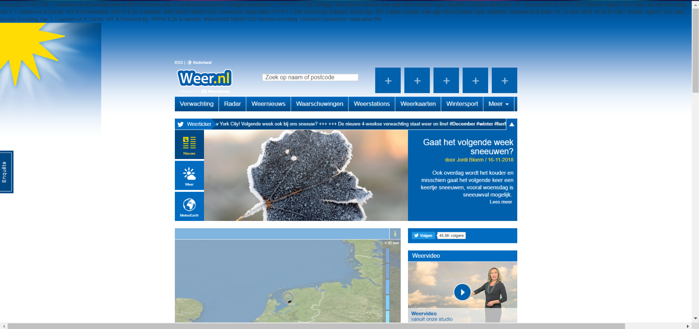

Trying 52.214.61.159...

Connected to b2cwebsite-live-lb-960116390.eu-west-1.elb.amazonaws.com.

Escape character is '^]'.

HTTP/1.1 200 OK

Age: 482

Cache-Control: max-age=600

Content-Type: text/html; charset=utf-8

Date: Fri, 16 Nov 2018 14:25:51 GMT

Server: nginx/1.12.0

Vary: Accept-Encoding

Via: 1.1 varnish-v4

X-Cache: HIT

X-Powered-By: PHP/5.5.26

X-Varnish: 998736255 998381352

Connection: keep-alive

HTTP/1.1 200 OK

Accept-Ranges: bytes

Age: 507

Cache-Control: max-age=600

Content-Type: text/html; charset=utf-8

Date: Fri, 16 Nov 2018 14:25:51 GMT

Server: nginx/1.12.0

Vary: Accept-Encoding

Via: 1.1 varnish-v4

X-Cache: HIT

X-Powered-By: PHP/5.5.26

X-Varnish: 996440008 998381352

transfer-encoding: chunked

Connection: keep-alive

f96

<!DOCTYPE html>

<html lang="nl">

<head>

<meta charset="utf-8">

<!--

This website is powered by TYPO3 - inspiring people to share!

TYPO3 is a free open source Content Management Framework initially created by Kasper Skaarhoj and licensed under GNU/GPL.

TYPO3 is copyright 1998-2014 of Kasper Skaarhoj. Extensions are copyright of their respective owners.

Information and contribution at http://typo3.org/

-->

<base href="http://www.weer.nl/">

<link rel="shortcut icon" href="http://www.weer.nl/fileadmin/favicon.ico" type="image/x-icon; charset=binary">

<link rel="icon" href="http://www.weer.nl/fileadmin/favicon.ico" type="image/x-icon; charset=binary">

<title>Weer, weersverwachting Nederland en buien radar - Weer.nl</title>

<meta name="generator" content="TYPO3 6.2 CMS">

<link rel="stylesheet" type="text/css" href="/fileadmin/styles/bootstrap.min.css?v=1.0.14&amp;1534237242" media="screen" title="screen">

<link rel="stylesheet" type="text/css" href="/fileadmin/scripts/jquery-ui/css/ui-lightness/jquery-ui-1.11.1.min.css?v=1.0.14&amp;1534237242" media="screen" title="screen">

<link rel="stylesheet" type="text/css" href="/fileadmin/styles/font-awesome.min.css?v=1.0.14&amp;1534237242" media="screen" title="screen">

<link rel="stylesheet" type="text/css" href="/fileadmin/styles/jquery.smartbanner.css?v=1.0.14&amp;1534237244" media="screen" title="screen">

<link rel="stylesheet" type="text/css" href="/fileadmin/wme/css/MG.Map.css?v=1.0.14&amp;1534237244" media="screen" title="screen">

<link rel="stylesheet" type="text/css" href="/fileadmin/styles/jquery-jvectormap-2.0.0.css?v=1.0.14&amp;1534237244" media="screen" title="screen">

<link rel="stylesheet" type="text/css" href="/fileadmin/styles/custom.css?v=1.0.14&amp;1534237242" media="screen" title="screen">

<script src="/fileadmin/scripts/moment-with-locales.min.js?v=1.0.14&amp;1534237242" type="text/javascript"></script>

<script src="/fileadmin/scripts/moment-timezone-with-data.min.js?v=1.0.14&amp;1534237242" type="text/javascript"></script>

<script src="/fileadmin/scripts/json2.min.js?v=1.0.14&amp;1534237242" type="text/javascript"></script>

<script src="//ajax.googleapis.com/ajax/libs/jquery/1.10.2/jquery.min.js" type="text/javascript"></script>

<script src="/fileadmin/scripts/jmespath.min.js?v=1.0.14&amp;1534237242" type="text/javascript"></script>

<script src="/fileadmin/scripts/utilsGlobal.min.js?v=1.0.14&amp;1534237242" type="text/javascript"></script>

<script src="/fileadmin/scripts/utilsDesktop.min.js?v=1.0.14&amp;1534237242" type="text/javascript"></script>

<script src="/fileadmin/scripts/jQuery-Storage-API-master/jquery.storageapi.min.js?v=1.0.14&amp;1534237242" type="text/javascript"></script>

<script src="/fileadmin/scripts/underscore.min.js?v=1.0.14&amp;1534237242" type="text/javascript"></script>

<script src="/fileadmin/scripts/OpenLayers/OpenLayers.min.js?v=1.0.14&amp;1534237242" type="text/javascript"></script>

<script src="/fileadmin/wme/js/jquery/jquery.outerhtml.js?v=1.0.14&amp;1534237245" type="text/javascript"></script>

<script src="/fileadmin/scripts/HomepageRadar.js?v=1.0.14&amp;1534237242" type="text/javascript"></script>

<script src="/fileadmin/scripts/jquery-jvectormap-2.0.0.min.js?v=1.0.14&amp;1534237242" type="text/javascript"></script>

<script src="/fileadmin/scripts/mapsHelper.js?v=1.0.14&amp;1534237242" type="text/javascript"></script>

<meta http-equiv="X-UA-Compatible" content="IE=EDGE" /> <meta name="google-site-verification" content="yzo4P37A8CupNOGe6A3-vGO2QxgMJKYZoplg512RLg0" /> <meta name="google-play-app" content="app-id=com.mg.android"> <meta name="viewport" content="width=device-width, initial-scale=1"> <link rel="apple-touch-icon" sizes="57x57" href="http://static.forecast-web.consumer.meteogroup.com/mobile/images/misc/homescreen/Homescreen57.png" />

<link rel="apple-touch-icon" sizes="72x72" href="http://static.forecast-web.consumer.meteogroup.com/mobile/images/misc/homescreen/Homescreen72.png" />

<link

706a

rel="apple-touch-icon" sizes="76x76" href="http://static.forecast-web.consumer.meteogroup.com/mobile/images/misc/homescreen/Homescreen76.png" />

<link rel="apple-touch-icon" sizes="114x114" href="http://static.forecast-web.consumer.meteogroup.com/mobile/images/misc/homescreen/Homescreen114.png" />

<link rel="apple-touch-icon" sizes="120x120" href="http://static.forecast-web.consumer.meteogroup.com/mobile/images/misc/homescreen/Homescreen120.png" />

<link rel="apple-touch-icon" sizes="144x144" href="http://static.forecast-web.consumer.meteogroup.com/mobile/images/misc/homescreen/Homescreen144.png" />

<link rel="apple-touch-icon" sizes="152x152" href="http://static.forecast-web.consumer.meteogroup.com/mobile/images/misc/homescreen/Homescreen152.png" />

<link rel="apple-touch-icon" sizes="180x180" href="http://static.forecast-web.consumer.meteogroup.com/mobile/images/misc/homescreen/Homescreen180.png" />

<script type='text/javascript'>

var googletag = googletag || {};

googletag.cmd = googletag.cmd || [];

(function() {

var gads = document.createElement('script');

gads.async = true;

gads.type = 'text/javascript';

var useSSL = 'https:' == document.location.protocol;

gads.src = (useSSL ? 'https:' : 'http:') +

'//www.googletagservices.com/tag/js/gpt.js';

var node = document.getElementsByTagName('script')[0];

node.parentNode.insertBefore(gads, node);

})();

</script>

<script type='text/javascript'>

googletag.cmd.push(function() {

googletag.defineSlot('/10482933/W24_NL_Start_160x600', [160, 600], 'div-gpt-ad-1434111168859-0').addService(googletag.pubads());

googletag.defineSlot('/10482933/W24_NL_Start_300x250', [[300, 600], [300, 250]], 'div-gpt-ad-1434111168859-2').addService(googletag.pubads());

googletag.defineSlot('/10482933/W24_NL_Start_728x90', [[728, 90], [970, 90]], 'div-gpt-ad-1434111168859-3').addService(googletag.pubads());

googletag.defineSlot('/10482933/W24_DE_Rot_1x1', [1, 1], 'div-gpt-ad-1434111168859-1').addService(googletag.pubads());

googletag.defineSlot('/10482933/W24_nl_mobile_Start_300x250', [300, 250], 'div-gpt-ad-1434110466757-0').addService(googletag.pubads());

googletag.defineSlot('/10482933/W24_NL_mobile_Start_320x50', [320, 50], 'div-gpt-ad-1434110466757-1').addService(googletag.pubads());

googletag.pubads().enableSingleRequest();

googletag.enableServices();

});

</script>

<script>

var gaProperty = 'UA-859740-1';

// Disable tracking if the opt-out cookie exists.

var disableStr = 'ga-disable-' + gaProperty;

if (document.cookie.indexOf(disableStr + '=true') > -1) {

window[disableStr] = true;

}

// Opt-out function

function gaOptout() {

document.cookie = disableStr + '=true; expires=Thu, 31 Dec 2099 23:59:59 UTC; path=/';

window[disableStr] = true;

alert("Google Analytics is uitgeschakeld. Vernieuw de site.");

}

(function(i,s,o,g,r,a,m){i['GoogleAnalyticsObject']=r;i[r]=i[r]||function(){

(i[r].q=i[r].q||[]).push(arguments)},i[r].l=1*new Date();a=s.createElement(o),

m=s.getElementsByTagName(o)[0];a.async=1;a.src=g;m.parentNode.insertBefore(a,m)

})(window,document,'script','//www.google-analytics.com/analytics.js','ga');

var a = 1;

ga('create', 'UA-859740-1', 'auto');

ga('require', 'linkid', 'linkid.js');

ga('require', 'displayfeatures');

ga('send', 'pageview');

</script>

<!--[if lte IE 9]>

<link rel="stylesheet" type="text/css" href="/fileadmin/styles/ie9-and-down.css" />

<script src="/fileadmin/scripts/html5shiv.min.js"></script>

<![endif]-->

<script type="text/javascript">

$().ready(function() {

$('.eTrack_emailSub').click(function(){

ga('send', 'event', 'EmailSubscribe', 'click', 'subscribe');

});

});

</script> <script type="text/javascript">

$().ready(function() {

$('#MGMap_home_01 .MGMapHeader .padder').addClass("eTrack_front_mapLayers");

$('.eTrack_billboard_news').click(function(){

ga('send', 'event', 'BillboardTabs', 'click', 'news');

});

$('.eTrack_billboard_forecast').click(function(){

ga('send', 'event', 'BillboardTabs', 'click', 'forecast');

});

$('.eTrack_billboard_meteoearth').click(function(){

ga('send', 'event', 'BillboardTabs', 'click', 'meteoearth');

});

$('.eTrack_billboard_toggle').click(function(){

ga('send', 'event', 'Toggle', 'click', 'billboard');

});

$('.eTrack_billboard_14days').click(function(){

ga('send', 'event', 'CallToAction', 'click', '14daysforecast');

});

$('.eTrack_CTA_forecastmap').click(function(){

ga('send', 'event', 'CallToAction', 'click', 'forecast');

});

$('.eTrack_CTA_radar').click(function(){

ga('send', 'event', 'CallToAction', 'click', 'radar');

});

$('.eTrack_CTA_radar').click(function(){

ga('send', 'event', 'Toggle', 'click', 'weathersymbol');

});

$('.eTrack_twitterticker').click(function(){

ga('send', 'event', 'Social', 'click', 'twitterTicker');

});

$('.eTrack_front_mapLayers').click(function(){

ga('send', 'event', 'Map', 'click', 'switchLayers');

});

});

</script> <script type="application/ld+json">

{

"@context": "http://schema.org",

"@type": "WebSite",

"url": "http://beta.weer.nl/",

"potentialAction": {

"@type": "SearchAction",

"target": "http://beta.weer.nl/zoecken/?s={search_term_string}",

"query-input": "required name=search_term_string"

}

}

</script><meta name="google-site-verification" content="yzo4P37A8CupNOGe6A3-vGO2QxgMJKYZoplg512RLg0" />

<link rel="canonical" href="http://www.weer.nl/">

<meta name="description" content="Het actuele weer, weer, 7-14 daagse verwachting, waarschuwingen voor noodweer en radar- en satellietbeelden van uw plaats online op Weer.nl"/>

<meta name="keywords" content=""/>

<link rel="alternate" media="only screen and (max-width: 768px)" href="http://www.weer.nl/mobiel/" >

<meta property="al:ios:app_name" content="WeatherPro">

<meta property="al:ios:app_store_id" content="294631159">

<meta property="al:ios:app_name" content="WeatherPro (free)">

<meta property="al:ios:app_store_id" content="997728895">

</head>

<body>

<div class="mg_outer clearfix">

<a href="https://plus.google.com/115265703645933585128" rel="publisher"></a>

<div class="container">

<header>

<div class="row ads">

<div class="span12 leaderboard">

<div id="ads_top">

<!-- 728x90, 970x90 -->

<div id='div-gpt-ad-1434111168859-3'>

<script type='text/javascript'>

googletag.cmd.push(function() { googletag.display('div-gpt-ad-1434111168859-3'); });

</script>

</div>

</div>

</div>

</div>

<div class="row social">

<div class="span12">

<!-- 1x1 -->

<div id='div-gpt-ad-1434111168859-1' style='height:1px; width:1px;'>

<script type='text/javascript'>

googletag.cmd.push(function() { googletag.display('div-gpt-ad-1434111168859-1'); });

</script>

</div>

<div id="ads_right">

<!-- 160x600 -->

<div id='div-gpt-ad-1434111168859-0' style='height:600px; width:160px;'>

<script type='text/javascript'>

googletag.cmd.push(function() { googletag.display('div-gpt-ad-1434111168859-0'); });

</script>

</div>

</div>

<div class="mg_social">

<a target="_blank" href="/rss.xml" title="RSS">RSS</a> |

<!--<a target="_blank" href="http://www.facebook.com/pages/Berlin/MeteoGroup-Deutschland/55258556378" title="Facebook">Facebook</a> |

<a target="_blank" href="http://twitter.com/wetter24" title="Twitter">Twitter</a> |

<a target="_blank" href="#" title="Google+">Google+</a>-->

</div>

<div class="mg_user">

<div id="flags">

<div class="headline" onclick="toggle_visibility(jQuery('#flags .links'))">

<img src="/fileadmin/styles/img/maps_btn.png" style="width: 15px; height: 15px;"/>

Nederland

</div>

</div>

<br style="clear:both" />

</div>

</div>

</div>

<div class="row">

<div class="span3 mg_logo">

<a href="/"><img src="fileadmin/styles/img/wsym/wetter24-NE.png" width="131" height="61" alt="Weer.nl Logo" title="Home" border="0"></a>

</div>

<div class="span3 mg_search">

<div class="searchbar-wrapper">

<form id="search_form" method="get" action="/zoeken/">

<input id="search" name="s" type="text" value="Zoek op naam of postcode" data-defaultText="Zoek op naam of postcode" />

<a id="favouriteHint" title="Zoek nieuwe favorieten"></a>

<a id="stringlengthHint" title="Voert u a.u.b. minimaal 3 karakters in!"></a>

</form>

<form id="newFavouriteFromSearch" method="post" action="">

<input type="hidden" name="newFavourite" value="true" />

<input type="hidden" name="city" id="newFavouriteFromSearchId" />

</form>

<input id="searchvalue" type="hidden" value="" />

<img src="/fileadmin/wme/images/layout/spinner.gif" class="autocompleteLoadIcon invisible">

</div>

<script type="text/javascript">

$(document).ready(function() {

searchBox.renderSearchBox();

/* Init tooltips above search input */

$('#favouriteHint').tooltip({

//use 'of' to link the tooltip to your specified input

position: { of: '#search', my: 'center bottom', at: 'center top-10' },

tooltipClass: "search-tooltip"

});

$('#stringlengthHint').tooltip({

//use 'of' to link the tooltip to your specified input

position: { of: '#search', my: 'center bottom', at: 'center top-10' },

tooltipClass: "search-tooltip"

});

});

</script>

</div>

<div class="span6 mg_favs ohwn">

<ul class="clearfix favList">

<li class="favourite no0 linkWrapper notSet">

<a onclick="addFavourite(event)">

<i>+</i>

</a>

</li>

<li class="favourite no1 linkWrapper notSet">

<a onclick="addFavourite(event)">

<i>+</i>

</a>

</li>

<li class="favourite no2 linkWrapper notSet">

<a onclick="addFavourite(event)">

<i>+</i>

</a>

</li>

<li class="favourite no3 linkWrapper notSet">

<a onclick="addFavourite(event)">

<i>+</i>

</a>

</li>

<li class="favourite no4 linkWrapper notSet">

<a onclick="addFavourite(event)">

<i>+</i>

</a>

</li>

</ul>

<script type='text/javascript'>

var pageLoaded = true;

var cities;

var activeCity;

var isHomePage = true;

var pageCity = "";

var defaultSlot = "<li class=\"favourite no[REPLACESLOT] linkWrapper notSet\"><a onclick=\"addFavourite(event)\"><i>+</i></a></li>";

var favouriteControls = new Array();

favouriteControls["first"] = "<div class=\"FavouriteNav no[REPLACESLOT]\"><div class=\"navWrapper\"><i class=\"fa fa-chevron-right\" onclick=\"moveFavouriteRight([REPLACEPOSITION])\"></i></div><div class=\"close\"><i class=\"fa fa-times\" onclick=\"removeFavourite([REPLACEPOSITION])\"></i></div></div>";

favouriteControls["middle"] = "<div class=\"FavouriteNav no[REPLACESLOT]\"><div class=\"navWrapper\"><i class=\"fa fa-chevron-right\" onclick=\"moveFavouriteRight([REPLACEPOSITION])\"></i><i class=\"fa fa-chevron-left\" onclick=\"moveFavouriteLeft([REPLACEPOSITION])\"></i></div><div class=\"close\"><i class=\"fa fa-times\" onclick=\"removeFavourite([REPLACEPOSITION])\"></i></div></div>";

favouriteControls["last"] = "<div class=\"FavouriteNav no[REPLACESLOT]\"><div class=\"navWrapper\"><i class=\"fa fa-chevron-left\" onclick=\"moveFavouriteLeft([REPLACEPOSITION])\"></i></div><div class=\"close\"><i class=\"fa fa-times\" onclick=\"removeFavourite([REPLACEPOSITION])\"></i></div></div>";

var favouriteTileUrl = "/ajax/favoriet/?lid=";

var favouriteDetailUrl = "/ajax/favouritedetails/?city=";

var defaultCities = new Array(

"1812872"

,"1811359"

,"1811978"

,"189296"

);

var defaultCity = "1812872";

initializeFavourites();

showFavourites();

function showFavouriteHind(){

$(document).ready(function() {

$("#search").focus();

$('#favouriteHint').tooltip({

open: function (e) {

setTimeout(function () {

$(e.target).tooltip('close');

}, 2000);

}

});

$('#favouriteHint').tooltip('open');

});

}

</script>

</div>

</div>

<nav class="row"> <!-- begin nav -->

<ul class="span12 navbar clearfix nl_nl">

<li class="first item0 ">

<a class="" href="/verwachting/kaart/europa/nederland/" title="">Verwachting</a>

<ul>

<li class="first item0 ">

<a href="/verwachting/kaart/europa/nederland/" title="">Nederland</a>

</li>

<li class=" item1 ">

<a href="/verwachting/kaart/europa/" title="">Europa</a>

</li>

<li class=" item2 ">

<a href="/verwachting/kaart/afrika/" title="">Afrika</a>

</li>

<li class=" item3 ">

<a href="/verwachting/kaart/oceanie/" title="">Oceanië</a>

</li>

<li class=" item4 ">

<a href="/verwachting/kaart/noord-amerika/" title="">Noord-Amerika</a>

</li>

<li class=" item5 ">

<a href="/verwachting/kaart/zuid-amerika/" title="">Zuid-Amerika</a>

</li>

<li class=" item6 ">

<a href="/verwachting/kaart/azie/" title="">Azië</a>

</li>

<li class=" item7 last">

<a href="/verwachting/kaart/midden-amerika/" title="">Midden-Amerika</a>

</li>

</ul>

</li>

<li class=" item1 ">

<a class="" href="/regenradar/nederland/" title="">Radar</a>

<ul>

<li class="first item0 ">

<a href="/regenradar/nederland/" title="">Nederland</a>

</li>

<li class=" item1 ">

<a href="/regenradar/duitsland/" title="">Duitsland</a>

</li>

<li class=" item2 ">

<a href="/regenradar/groot-brittannie/" title="">Groot-Brittannië</a>

</li>

<li class=" item3 ">

<a href="/regenradar/belgie/" title="">België</a>

</li>

<li class=" item4 ">

<a href="/regenradar/frankrijk/" title="">Frankrijk</a>

</li>

<li class=" item5 ">

<a href="/regenradar/zwitserland/" title="">Zwitserland</a>

</li>

<li class=" item6 last">

<a href="/regenradar/europa/" title="">Europa</a>

</li>

</ul>

</li>

<li class=" item2 ">

<a class="" href="/nieuws/" title="">Weernieuws</a>

<ul>

<li class="first item0 ">

<a href="/nieuws/" title="">Nieuws</a>

</li>

<li class=" item1 ">

<a href="/weervideo/" title="">Weervideo</a>

</li>

<li class=" item2 last">

<a href="/nieuws/30-daagse-verwachting/" title="">30 Daagse Verwachting</a>

</li>

</ul>

</li>

<li class=" item3 ">

<a class="" href="/alarm/" title="">Waarschuwingen</a>

</li>

<li class=" item4 ">

<a class="" href="/weerstations/" title="">Weerstations</a>

</li>

<li class=" item5 ">

<a class="" href="/weerkaarten/gfs/" title="">Weerkaarten</a>

<ul>

<li class="first item0 ">

<a href="/weerkaarten/gfs/" title="">GFS (NCEP)</a>

</li>

<li class=" item1 ">

<a href="/weerkaarten/ecmwf/" title="">ECMWF</a>

</li>

<li class=" item2 last">

<a href="/satelliet/europa/" title="">Satelliet</a>

</li>

</ul>

</li>

<li class=" item6 ">

<a class="" href="/wintersportweer/" title="">Wintersport</a>

</li>

<li class=" item7 last">

<span class="">Meer<img src="/fileadmin/styles/img/down.png" /></span>

<ul>

<li class="first item0 ">

<a href="/meer/weer-voor-op-de-homepage-weernl/?city=1812872" title="">Widget</a>

</li>

<li class=" item1 ">

<a href="/meer/weer-apps/" title="">Weer Apps</a>

</li>

<li class=" item2 ">

<a href="/weerfoto-upload/" title="">Weerfoto</a>

</li>

<li class=" item3 last">

<a href="/meer/workshops/" title="">Bedrijfsuitjes &amp; Lezingen</a>

</li>

</ul>

</li>

</ul>

</nav> <!-- end nav -->

</header>

<div class="banner_teaser ohwn">

<div class="twitter-ticker eTrack_twitterticker">

<div class="title">

<a href="https://twitter.com/MeteoGroupWeer">

<img src="http://static.forecast-web.consumer.meteogroup.com/ui/images/social/twitter-ticker.png"/>

<span class="text">

Weerticker

</span>

</a>

</div>

<div class="marquee">

<span>

+++ Gisteren flink wat sneeuw in New York City! Volgende week ook bij ons sneeuw?<a target="_blank" href="https://t.co/UoW8K7Ync1" rel="nofollow noopener" dir="ltr" data-expanded-url="https://youtu.be/JIgLjRoBgrQ" class="twitter-timeline-link u-hidden" target="_blank" title="https://youtu.be/JIgLjRoBgrQ" ><span class="tco-ellipsis"></span><span class="invisible">https://</span><span class="js-display-url">youtu.be/JIgLjRoBgrQ</span><span class="invisible"></span><span class="tco-ellipsis"><span class="invisible">&nbsp;</span></span></a> +++

+++ De nieuwe 4-weekse verwachting staat weer on line! <a target="_blank" href="http://twitter.com/hashtag/December?src=hash" data-query-source="hashtag_click" class="twitter-hashtag pretty-link js-nav" dir="ltr" ><s>#</s><b>December</b></a> <a target="_blank" href="http://twitter.com/hashtag/winter?src=hash" data-query-source="hashtag_click" class="twitter-hashtag pretty-link js-nav" dir="ltr" ><s>#</s><b>winter</b></a> <a target="_blank" href="http://twitter.com/hashtag/herfst?src=hash" data-query-source="hashtag_click" class="twitter-hashtag pretty-link js-nav" dir="ltr" ><s>#</s><b>herfst</b></a> zie: <a target="_blank" href="https://t.co/1jAH5LuQCO" rel="nofollow noopener" dir="ltr" data-expanded-url="http://www.weer.nl/nieuws/30-daagse-verwachting/" class="twitter-timeline-link" target="_blank" title="http://www.weer.nl/nieuws/30-daagse-verwachting/" ><span class="tco-ellipsis"></span><span class="invisible">http://www.</span><span class="js-display-url">weer.nl/nieuws/30-daag</span><span class="invisible">se-verwachting/</span><span class="tco-ellipsis"><span class="invisible">&nbsp;</span>&hellip;</span></a> foto van Margreet van Vianen <a target="_blank" href="http://twitter.com/hashtag/maandverwachting?src=hash" data-query-source="hashtag_click" class="twitter-hashtag pretty-link js-nav" dir="ltr" ><s>#</s><b>maandverwachting</b></a><a target="_blank" href="https://t.co/djgzP44RWU" class="twitter-timeline-link u-hidden" data-pre-embedded="true" dir="ltr" >pic.twitter.com/djgzP44RWU</a> +++

+++ Ook de middagtemperaturen gaan omlaag. De kou kan volgende week een keer met sneeuw gepaard gaan. Meer: <a target="_blank" href="https://t.co/XpW8SEFWwd" rel="nofollow noopener" dir="ltr" data-expanded-url="https://bit.ly/2zbDufQ" class="twitter-timeline-link" target="_blank" title="https://bit.ly/2zbDufQ" ><span class="tco-ellipsis"></span><span class="invisible">https://</span><span class="js-display-url">bit.ly/2zbDufQ</span><span class="invisible"></span><span class="tco-ellipsis"><span class="invisible">&nbsp;</span></span></a><a target="_blank" href="https://t.co/14CEYtXXUY" class="twitter-timeline-link u-hidden" data-pre-embedded="true" dir="ltr" >pic.twitter.com/14CEYtXXUY</a> +++

+++ In New York slaat de winter nu al toe...<a target="_blank" href="https://t.co/XA6aI7AdrI" rel="nofollow noopener" dir="ltr" data-expanded-url="https://twitter.com/wolvenne/status/1063308519913504769" class="twitter-timeline-link u-hidden" target="_blank" title="https://twitter.com/wolvenne/status/1063308519913504769" ><span class="tco-ellipsis"></span><span class="invisible">https://</span><span class="js-display-url">twitter.com/wolvenne/statu</span><span class="invisible">s/1063308519913504769</span><span class="tco-ellipsis"><span class="invisible">&nbsp;</span>&hellip;</span></a> +++

+++ We hebben een koude nacht achter de rug. In de <a target="_blank" href="http://twitter.com/hashtag/Achterhoek?src=hash" data-query-source="hashtag_click" class="twitter-hashtag pretty-link js-nav" dir="ltr" ><s>#</s><b>Achterhoek</b></a> heeft het in Hupsel 3,6 graden gevroren, aan de grond -5,1! <a target="_blank" href="http://twitter.com/hashtag/weer?src=hash" data-query-source="hashtag_click" class="twitter-hashtag pretty-link js-nav" dir="ltr" ><s>#</s><b>weer</b></a> <a target="_blank" href="http://twitter.com/hashtag/koud?src=hash" data-query-source="hashtag_click" class="twitter-hashtag pretty-link js-nav" dir="ltr" ><s>#</s><b>koud</b></a><a target="_blank" href="https://t.co/Q6Zs651pMB" class="twitter-timeline-link u-hidden" data-pre-embedded="true" dir="ltr" >pic.twitter.com/Q6Zs651pMB</a> +++

</span>

</div>

</div>

<div class="billboard billboard-forecast no-display">

<div class="tabs news">

<a onClick="stopBillboardRotation('.billboard-news');">

<div class="tab eTrack_billboard_news" style="background-image:url(http://static.forecast-web.consumer.meteogroup.com/billboard/images/news_w.png)">

<div class="white caption">Nieuws</div>

</div>

</a>

<div class="spacer"></div>

<a onClick="stopBillboardRotation('.billboard-forecast');">

<div class="tab forecast active eTrack_billboard_forecast" style="background-image:url(http://static.forecast-web.consumer.meteogroup.com/billboard/images/weather_y.png)">

<div class="yellow caption">Weer</div>

</div>

</a>

<div class="spacer"></div>

<a onClick="stopBillboardRotation('.billboard-meteoearth');">

<div class="tab meteoearth eTrack_billboard_meteoearth" style="background-image:url(http://static.forecast-web.consumer.meteogroup.com/billboard/images/maps_w.png)">

<div class="white caption">MeteoEarth</div>

</div>

</a>

</div>

<div class="homepage-forecast billboard-content no-display">

</div>

</div>

<div class="billboard billboard-news">

<div class="tabs news">

<a onClick="stopBillboardRotation('.billboard-news');">

<div class="tab active eTrack_billboard_news" style="background-image:url(http://static.forecast-web.consumer.meteogroup.com/billboard/images/news_y.png)">

<div class="yellow caption">Nieuws</div>

</div>

</a>

<div class="spacer"></div>

<a onClick="stopBillboardRotation('.billboard-forecast');">

<div class="tab forecast eTrack_billboard_forecast" style="background-image:url(http://static.forecast-web.consumer.meteogroup.com/billboard/images/weather_w.png)">

<div class="white caption">Weer</div>

</div>

</a>

<div class="spacer"></div>

<a onClick="stopBillboardRotation('.billboard-meteoearth');">

<div class="tab meteoearth eTrack_billboard_meteoearth" style="background-image:url(http://static.forecast-web.consumer.meteogroup.com/billboard/images/maps_w.png)">

<div class="white caption">MeteoEarth</div>

</div>

</a>

</div>

<div class="homepage-news billboard-content">

b48

<div class="img-wrap">

<div class="news-img-outer-wrap">

<a href="nieuws/detail/2018-11-16-gaat-het-volgende-week-sneeuwen/">

<img src="/uploads/tx_news/560/Ben_Saanen_ijs_itverhaal.jpg" title="" alt="teaser"/>

</a>

</div>

</div>

<div class="teaserWrapper">

<a href="nieuws/detail/2018-11-16-gaat-het-volgende-week-sneeuwen/">

<div class="title">

Gaat het volgende week sneeuwen?

</div>

<div class="date">

<span class="news-list-author">

<!-- author -->

door Jordi Bloem

/

16-11-2018

</span>

</div>

<div class="teaser">

Ook overdag wordt het kouder en misschien gaat het volgende keer een keertje sneeuwen, vooral woensdag is sneeuwval mogelijk.

<br />

<a class="more-link" href="nieuws/detail/2018-11-16-gaat-het-volgende-week-sneeuwen/">

Lees meer

</a>

<br><br>

</div>

</a>

<!-- Social Media Icons. Disabled for now -->

<!-- <div class="mg_box_simple ohwn billboard-news-social-share">

<div class="social-container mail">

<a class="mail-share-button" href=""></a>

</div>

<div class="social-container facebook">

<span class="facebook-share-button"></span>

<span class="facebook-share-count"></span>

</div>

<div class="social-container twitter">

<span class="twitter-share-button"

6028

></span>

<span class="twitter-share-count"></span>

</div>

<div class="social-container google">

<span class="google-share-button"></span>

<span class="google-share-count"></span>

</div>

</div> -->

</div>

</div>

</div>

<div class="billboard billboard-meteoearth no-display">

<div class="tabs news">

<a onClick="stopBillboardRotation('.billboard-news');">

<div class="tab eTrack_billboard_news" style="background-image:url(http://static.forecast-web.consumer.meteogroup.com/billboard/images/news_w.png)">

<div class="white caption">Nieuws</div>

</div>

</a>

<div class="spacer"></div>

<a onClick="stopBillboardRotation('.billboard-forecast');">

<div class="tab forecast eTrack_billboard_forecast" style="background-image:url(http://static.forecast-web.consumer.meteogroup.com/billboard/images/weather_w.png)">

<div class="white caption">Weer</div>

</div>

</a>

<div class="spacer"></div>

<a onClick="stopBillboardRotation('.billboard-meteoearth');">

<div class="tab meteoearth active eTrack_billboard_meteoearth" style="background-image:url(http://static.forecast-web.consumer.meteogroup.com/billboard/images/maps_y.png)">

<div class="yellow caption">MeteoEarth</div>

</div>

</a>

</div>

<div class="homepage-meteoearth billboard-content">

<a href="http://www.meteoearth.com/" >

<img src="http://static.forecast-web.consumer.meteogroup.com/billboard/images/meteoearth-banner.png" title="MeteoEarth" alt="MeteoEarth - The revolutionary new Weather App"/>

</a>

<div id='meDiv' style='width:860px;height:250px;top:-250px;background:#000;position:relative;'></div>

<script type='text/javascript'>

var conditionalyCreateMEView = function(compatibility) {

if((!compatibility.isCompatible || compatibility.isMobile)) {

document.getElementById('meDiv').style.display = "none";

} else {

var meConfig={

div : document.getElementById('meDiv'),

viewSettings : {longitude: 8.0533,latitude: 47.4679,zoom:7.2936,is3DEnabled:false,isLightingEnabled:false, isPrecipitationEnabled:true, isWindEnabled:true, automaticallyChaseStorms: 5000, isTropicalStormEnabled: true},

onUpdate : function(deltaTime) {

me.isEmbedded = false;

me.onCanvasResize();

}

};

var me = me_createView(meConfig);

}

};

</script>

</div>

</div>

<div class="billboard-flap eTrack_billboard_toggle"></div>

</div>

<div class="row row_main">

<div class="span8">

<div class="mg_box_simple">

<div id="MGMap_home_01" class="MGMap">

<div class="MGMapOptions MGMapHeader">

<h2>

<span class="padder"></span>

<span class="MGMapTitle"></span>

<span class="MGMapTimeDisplayNew"></span>

<a class="keyToggle item active"></a>

</h2>

</div>

<div class="MGMapCanvas"></div>

<div class="MGMapKey radar active">

<p class="max">

> 32 mm

</p>

<ul class="levels">

<li class="level-6"></li>

<li class="level-5"></li>

<li class="level-4"></li>

<li class="level-3"></li>

<li class="level-2"></li>

<li class="level-1"></li>

<li class="level-0"></li>

</ul>

<p class="min">

0,1 mm

</p>

</div>

<div class="MGMapKey temperature">

<div class="gradient">

<hr class="first" />

<hr />

<hr />

<hr />

<hr />

<hr />

<hr />

</div>

<ul class="gradientDivision">

<li class="division first">40°C</li>

<li class="division">20°C</li>

<li class="division">0°C</li>

<li class="division">-20°C</li>

</ul>

</div>

<div class="MGMapLoader">

<div class="MGMapLogo"></div>

<div class="MGMapSpinner"></div>

</div>

</div>

<div class="MapCTA CTAbar">

<a href="/verwachting/kaart/europa/nederland/" class="eTrack_CTA_forecastmap">Naar de weerkaart</a>&nbsp;&nbsp;|&nbsp;&nbsp;<a href="/radar/nederland/" class="eTrack_CTA_radar">Naar de regenradar</a>

</div>

</div>

<script type="text/javascript">

$(document).ready(function() {

var homepageRadarData = {

latitude: '53',

longitude: '5.6',

locale: 'nl_nl',

zoomLevel: '4.49',

minZoomLevel: '0',

maxZoomLevel: '5',

animationSpeedFactor: '5000',

translations: {

rad_eu: 'Regenradar',

tt3: 'Temperatuur',

sat_eu: 'Satelliet',

ne_rrr3: 'Bewolking'

},

context: 'home%2F6%2F31'

}

var homepageRadarComponent = new HomepageRadar(homepageRadarData);

$('#MGMap_home_01 .keyToggle').click(homepageRadarComponent.toggleKey);

});

</script>

<!-- Temp Map -->

<div class="card temp-map col-md-4 floatText">

<div class="card--header">

<button data-layer="temp" class="temp active">

Temp

</button>

<button data-layer="wind" class="wind">

Wind

</button>

<button data-layer="precipitation" class="precipitation">

Niederschlag

</button>

<h2>

Weersverwachting Nederland,

<span class="date">16.11.2018</span>

</h2>

</div>

<div class="card--content">

<div id="tempHome-6-31" class="temp-map--map">

<a href="/verwachting/kaart/europa/"><button type="button" title="Zurück zur Kontinentkarte" class="goBack">terug</button></a>

<div class="toggleNight">

<span>Dag</span><button type="button" title="Tag / Nacht" class="daytime"></button><span>Nacht</span>

</div>

</div>

<div class="secondaryNavigation">

<a href="/verwachting/kaart/europa/nederland/tijd/nu/"><button>actueel</button></a>

<a href="/verwachting/kaart/europa/nederland/dag/vrijdag/" class="active"><button>vandaag</button></a>

<a href="/verwachting/kaart/europa/nederland/dag/zaterdag/"><button>morgen</button></a>

</div>

<div class="weather-text-paragraph full">

<h3>

Verwachting voor 16.11.2018

</h3>

<p>Op diverse plaatsen is het eerst nog grijs of mistig, maar vanuit het oosten komt steeds vaker de zon erdoor. Het blijft droog. <br />Er waait een zwakke tot hooguit matige oostelijke wind en het wordt 8 graden aan de kust tot 11 graden in Limburg. <br />Vanavond en vannacht is het helder en het koelt af tot rond of iets onder het vriespunt. Morgen en zondag is het zonnig. Er waait een kille oostelijke wind en het wordt 6 tot 9 graden.<br /></p>

</div>

</div>

</div>

<script type="text/javascript">

$(document).ready(function () {

var clickMapConfig = {

id: 'tempHome-6-31',

dataURL_static: '/fileadmin/maps/tempHome/6/31/static.json',

dataURL_dyn: '/index.php?id=110'+

'&day=Friday'+

'&now='+

'&data_format=json&context=tempHome%2F6%2F31'+

'&map_id=59',

disableRegions: '0',

// zoomEnabled: true & zoomMax: 1 is needed to prevent zooming and panning on mobile devices (see mobile frontpage clickmap config)

zoomEnabled: '',

zoomMax: '',

forecastTargetPageId: '18',

locale: 'nl_nl'

};

var forecastClickMapComponent = new ForecastClickMap(clickMapConfig);

$layerButtons = $('button[data-layer]');

$daytimeButton = $('button.daytime');

/* Layer Switch */

$layerButtons.click(function() {

forecastClickMapComponent.switchForecastMapLayer(this.dataset.layer, $layerButtons);

});

/* Day/Night Switch */

$daytimeButton.click(function() {

forecastClickMapComponent.switchForecastMapDaytime(this);

});

forecastClickMapComponent.loadForecastMapLayers($layerButtons, $daytimeButton);

});

</script>

<div class="news">

<h2>Weernieuws</h2>

<div class="news-ticker">

<div class="news-item-wrapper">

<div class="left">

<div class="img-wrap">

<div class="news-img-outer-wrap">

<a href="nieuws/detail/2018-11-16-gaat-het-volgende-week-sneeuwen/">

<img src="/uploads/tx_news/133/Ben_Saanen_ijs_itverhaal.jpg" title="" alt="teaser"/>

</a>

</div>

</div>

</div>

<div class="middle">

<h3 class="title">

<a href="nieuws/detail/2018-11-16-gaat-het-volgende-week-sneeuwen/">

Gaat het volgende week sneeuwen?

</a>

</h3>

<div class="teaser">

Ook overdag wordt het kouder en misschien gaat het volgende keer een keertje sneeuwen, vooral woensdag is sneeuwval mogelijk.

<br>

<a href="nieuws/detail/2018-11-16-gaat-het-volgende-week-sneeuwen/">

Lees meer

</a>

</div>

<div class="social-share-news-item" data-urlpath="nieuws/detail/2018-11-16-gaat-het-volgende-week-sneeuwen/">

<div class="social-container facebook">

<div class="share-button"></div>

<span class="share-count">0</span>

</div>

<div class="social-container twitter">

<div class="share-button"></div>

<!--<span class="share-count"></span>-->

</div>

<div class="social-container google">

<div class="share-button"></div>

<span class="share-count">0</span>

</div>

</div>

</div>

<div class="right">

<div class="date-author">

<span class="date">

16-11-2018<br>

</span>

<!-- author -->

<span class="author">

door Jordi Bloem

</span>

</div>

</div>

</div>

<div class="news-item-wrapper">

<div class="left">

<div class="img-wrap">

<div class="news-img-outer-wrap">

<a href="nieuws/detail/2018-11-15-winterjassenweer/">

<img src="/uploads/tx_news/133/voorpag_Anne-Marie_van_Iersel.PNG" title="" alt="teaser"/>

</a>

</div>

</div>

</div>

<div class="middle">

<h3 class="title">

<a href="nieuws/detail/2018-11-15-winterjassenweer/">

Winterjassenweer

</a>

</h3>

<div class="teaser">

De oostelijke bries maakt de dagen almaar kouder

<br>

<a href="nieuws/detail/2018-11-15-winterjassenweer/">

Lees meer

</a>

</div>

<div class="social-share-news-item" data-urlpath="nieuws/detail/2018-11-15-winterjassenweer/">

<div class="social-container facebook">

<div class="share-button"></div>

<span class="share-count">0</span>

</div>

<div class="social-container twitter">

<div class="share-button"></div>

<!--<span class="share-count"></span>-->

</div>

<div class="social-container google">

<div class="share-button"></div>

<span class="share-count">0</span>

</div>

</div>

</div>

<div class="right">

<div class="date-author">

<span class="date">

15-11-2018<br>

</span>

<!-- author -->

<span class="author">

door Grieta Spannenburg

</span>

</div>

</div>

</div>

<div class="news-item-wrapper">

<div class="left">

<div class="img-wrap">

<div class="news-img-outer-wrap">

<a href="nieuws/detail/2018-11-14-reeks-met-koude-nachten-en-vroege-ochtenden-op-komst/">

<img src="/uploads/tx_news/133/Slide1Willy.PNG" title="" alt="teaser"/>

</a>

</div>

</div>

</div>

<div class="middle">

<h3 class="title">

<a href="nieuws/detail/2018-11-14-reeks-met-koude-nachten-en-vroege-ochtenden-op-komst/">

Reeks met vroege ochtenden op komst

</a>

</h3>

<div class="teaser">

De temperaturen gaan omlaag. Er komt een periode met koude nachten en koude vroege ochtenden aan. Ook in de middagen is het later kouder.

<br>

<a href="nieuws/detail/2018-11-14-reeks-met-koude-nachten-en-vroege-ochtenden-op-komst/">

Lees meer

</a>

</div>

<div class="social-share-news-item" data-urlpath="nieuws/detail/2018-11-14-reeks-met-koude-nachten-en-vroege-ochtenden-op-komst/">

<div class="social-container facebook">

<div class="share-button"></div>

<span class="share-count">0</span>

</div>

<div class="social-container twitter">

<div class="share-button"></div>

<!--<span class="share-count"></span>-->

</div>

<div class="social-container google">

<div class="share-button"></div>

<span class="share-count">0</span>

</div>

</div>

</div>

<div class="right">

<div class="date-author">

<span class="date">

14-11-2018<br>

</span>

<!-- author -->

<span class="author">

door Jordi Bloem

</span>

</div>

</div>

</div>

<script>

$( document ).ready(function() {

initSocialNewsItem("nl_nl");

});

</script>

</div>

</div>

<h2>meteogroupweer @Instagram</h2>

<div class="box-content">

<!-- www.intagme.com -->

<!--

<iframe src="http://www.intagme.com/in/?u=bWV0ZW9ncm91cHdlZXJ8aW58MTA1fDV8MXx8eWVzfDEwfHVuZGVmaW5lZHxubw==" allowTransparency="true" frameborder="0" scrolling="no" style="border:none; overflow:hidden; width:575px; height: 105px; margin-left: 10px" ></iframe>

-->

<!--

<iframe src="//www.instagram.com/meteogroupweer/" allowTransparency="true" frameborder="0" scrolling="no" style="border:none; overflow:hidden; width:575px; height: 105px; margin-left: 10px" ></iframe>

-->

Beleef het weer met ons mee, met dagelijks nieuwe weerfoto’s op het <a href="https://www.instagram.com/meteogroupweer/" target="_blank">MeteoGroup instagram account!</a>

<a href="https://www.instagram.com/meteogroupweer/" target="_blank"><img src="//s3-eu-west-1.amazonaws.com/static.forecast-web.consumer.meteogroup.com/teaser-instagram/nl_nl/weer_nl_teaser_instagram.jpg" alt="meteogroupweer" style="border:0;">

</a>

</div>

<br/>

</div>

<div class="span4">

<div class="socialFollowcontainer">

<div class="socialFollowFacebook">

<!--<div class="fb-like" data-href="https://www.facebook.com/MeteoGroupWeer" data-layout="button_count" data-action="like" data-show-faces="false" data-share="false"></div>-->

</div>

<div class="socialFollowTwitter">

<iframe

src="//platform.twitter.com/widgets/follow_button.html?screen_name=MeteoGroupWeer&lang=nl&show_screen_name=false"

style="width: 300px; height: 20px;"

allowtransparency="true"

frameborder="0"

scrolling="no">

</iframe>

</div>

<!--

<div class="socialFollowGoogle">

<div class="g-follow" data-annotation="none" data-height="20" data-href="https://plus.google.com/117615129452525175649" data-rel="publisher"></div>

</div>

-->

<div id="fb-root"></div>

<script>(function (d, s, id) {

var js, fjs = d.getElementsByTagName(s)[0];

if (d.getElementById(id))

return;

js = d.createElement(s);

js.id = id;

js.src = "//connect.facebook.net/nl_NL/sdk.js#xfbml=1&version=v2.4&appId=717768344978331";

fjs.parentNode.insertBefore(js, fjs);

}(document, 'script', 'facebook-jssdk'));</script>

</div><h2>Weervideo</h2>

<a title="Weervideo" href="/weervideo/">

<img width="300" height="170" border="0" alt="Weervideo" src="/fileadmin/user_upload/B2C_Teaser-videoshow_300x170_02.png">

</a><h2>Waarschuwingen voor Nederland</h2>

<a href="/alarm/">

<img src="http://alarm.noodweercentrale.nl/images/map/nederland_index.png">

</a>

<div class="AlertsCTA CTAbar"><a href="/alarm/">meer Waarschuwingen</a></div><h2>Weerfoto</h2>

<a title="Weerfoto" href="/weerfoto-upload/">

<img width="300" height="170" border="0" alt="Weervideo" src="http://static.forecast-web.consumer.meteogroup.com/weather-user-photo/nl_nl/teaser/teaser_weather-photo_300x170_02.png">

</a><div class="mg_box_simple temperatures-list">

<h2>

Reisweer

</h2>

<a href="/index.php?id=18&city=1884308">

<div class="row-fluid odd">

<div class="span12">

<div style="float:left;">

<p style="white-space: nowrap; max-width: 200px; overflow: hidden; text-overflow: ellipsis;"><img src="/fileadmin/styles/img/boxsymbols/blue-20x20/1199999.png">&nbsp;Palma de Mallorca</p>

</div>

<div style="margin-left: 220px;">

<span class="t_21" style="width: 20px; float:left;">&nbsp;</span>

</div>

<div style="float:right;">

<p class="temperatureRow_value" style="margin-left: 0;"><span class="value">21</span><span class="unit">°C</span></p>

</div>

</div>

</div>

</a>

<a href="/index.php?id=18&city=1881222">

<div class="row-fluid even">

<div class="span12">

<div style="float:left;">

<p style="white-space: nowrap; max-width: 200px; overflow: hidden; text-overflow: ellipsis;"><img src="/fileadmin/styles/img/boxsymbols/blue-20x20/1199999.png">&nbsp;Barcelona</p>

</div>

<div style="margin-left: 220px;">

<span class="t_19" style="width: 20px; float:left;">&nbsp;</span>

</div>

<div style="float:right;">

<p class="temperatureRow_value" style="margin-left: 0;"><span class="value">19</span><span class="unit">°C</span></p>

</div>

</div>

</div>

</a>

<a href="/index.php?id=18&city=1892456">

<div class="row-

1490

fluid odd">

<div class="span12">

<div style="float:left;">

<p style="white-space: nowrap; max-width: 200px; overflow: hidden; text-overflow: ellipsis;"><img src="/fileadmin/styles/img/boxsymbols/blue-20x20/1199999.png">&nbsp;Rimini</p>

</div>

<div style="margin-left: 220px;">

<span class="t_14" style="width: 20px; float:left;">&nbsp;</span>

</div>

<div style="float:right;">

<p class="temperatureRow_value" style="margin-left: 0;"><span class="value">14</span><span class="unit">°C</span></p>

</div>

</div>

</div>

</a>

<a href="/index.php?id=18&city=18558153">

<div class="row-fluid even">

<div class="span12">

<div style="float:left;">

<p style="white-space: nowrap; max-width: 200px; overflow: hidden; text-overflow: ellipsis;"><img src="/fileadmin/styles/img/boxsymbols/blue-20x20/1999999.png">&nbsp;Antalya</p>

</div>

<div style="margin-left: 220px;">

<span class="t_20" style="width: 20px; float:left;">&nbsp;</span>

</div>

<div style="float:right;">

<p class="temperatureRow_value" style="margin-left: 0;"><span class="value">20</span><span class="unit">°C</span></p>

</div>

</div>

</div>

</a>

<a href="/index.php?id=18&city=1862">

<div class="row-fluid odd">

<div class="span12">

<div style="float:left;">

<p style="white-space: nowrap; max-width: 200px; overflow: hidden; text-overflow: ellipsis;"><img src="/fileadmin/styles/img/boxsymbols/blue-20x20/1999999.png">&nbsp;Hurghada</p>

</div>

<div style="margin-left: 220px;">

<span class="t_27" style="width: 20px; float:left;">&nbsp;</span>

</div>

<div style="float:right;">

<p class="temperatureRow_value" style="margin-left: 0;"><span class="value">27</span><span class="unit">°C</span></p>

</div>

</div>

</div>

</a>

<a href="/index.php?id=18&city=1885171">

<div class="row-fluid even">

<div class="span12">

<div style="float:left;">

<p style="white-space: nowrap; max-width: 200px; overflow: hidden; text-overflow: ellipsis;"><img src="/fileadmin/styles/img/boxsymbols/blue-20x20/1299999.png">&nbsp;Santa Cruz</p>

</div>

<div style="margin-left: 220px;">

<span class="t_17" style="width: 20px; float:left;">&nbsp;</span>

</div>

<div style="float:right;">

<p class="temperatureRow_value" style="margin-left: 0;"><span class="value">17</span><span class="unit">°C</span></p>

</div>

</div>

</div>

</a>

<a href="/index.php?id=18&city=187290">

<div class="row-fluid odd">

<div class="span12">

<div style="float:left;">

<p style="white-space: nowrap; max-width: 200px; overflow: hidden; text-overflow: ellipsis;"><img src="/fileadmin/styles/img/boxsymbols/blue-20x20/1219999.png">&nbsp;Kreta</p>

</div>

<div style="margin-left: 220px;">

<span class="t_18" style="width: 20px; float:left;">&nbsp;</span>

</div>

<div style="float:right;">

<p class="temperatureRow_value" style="margin-left: 0;"><span class="value">18</span><span class="unit">°C</span></p>

</div>

</div>

</div>

</a>

<a href="/index.php?id=18&city=181779702">

<div class="row-fluid even">

<div class="span12">

<div style="float:left;">

<p style="white-space: nowrap; max-width: 200px; overflow: hidden; text-overflow: ellipsis;"><img src="/fileadmin/styles/img/boxsymbols/blue-20x20/2999999.png">&nbsp;Dubai</p>

</div>

<div style="margin-left: 220px;">

<span class="t_34" style="width: 20px; float:left;">&nbsp;</span>

</div>

<div style="float:right;">

<p class="temperatureRow_value" style="margin-left: 0;"><span class="value">34</span><span class="unit">°C</span></p>

</div>

</div>

</div>

</a>

</div>

<!-- 300x250, 300x600 -->

<div class="mg_box_ads clearfix">

<h2 class="small">Reclame</h2>

<div id='div-gpt-ad-1434111168859-2'>

<script type='text/javascript'>

googletag.cmd.push(function() { googletag.display('div-gpt-ad-1434111168859-2'); });

</script>

</div>

</div>

<div class="emailSub sidebar">

<h2 class="small">Abonneren op de nieuwsbrief</h2>

<img src="http://static.forecast-web.consumer.meteogroup.com/email-subscribe/nl_nl/hero.png" alt="Mijn weer.nl"/>

<div class="header">

<p class="first">Nu aanmelden voor de nieuwsbrief</p>

<p class="second">en nog meer weer ontvangen!</p>

</div>

<div class="box-content">

<ul class="benefits">

<li><i class="fa fa-check"></i> 1

1fd0

4-daagse weersverwachting</li>

<li><i class="fa fa-check"></i> Weerfavorieten</li>

<li><i class="fa fa-check"></i> Twitter weerticker</li>

<li><i class="fa fa-check"></i> Satellietbeelden</li>

</ul>

<div class="input">

<p class="error"></p>

<input type="text" placeholder="Uw E-mail" value="" name="" id="email" size="20" class="">

<input type="submit" value="Aanmelden" class="button secondary right eTrack_emailSub" name="">

<p class="success"></p>

</div>

</div>

</div>

<script type="text/javascript">

$(".emailSub.sidebar input[type='submit']").click(function(e) {

e.preventDefault();

var email = $('.emailSub.sidebar input#email').val();

if (email.indexOf("@") === -1) {

$(".emailSub.sidebar .error").html("Invalid Email!");

} else {

do_ajax(email);

}

});

function do_ajax(email) {

var email = email;

$.ajax({

url: "/fileadmin/mail/form.php",

type: "POST",

data: { email: email, locale: 'nl_nl' },

context: $(".emailSub.sidebar"),

success: function(data){

$('.input .success', this).html(data);

}

});

}

</script>

</div>

</div>

<footer>

<div class="row footer_line">

<span class="span_logo gen_logo">

<a href="http://www.meteogroup.com"><img title="MeteoGroup" src="/fileadmin/styles/img/meteogroup-logo.png" /></a>

</span>

<span class="span10 gen_links closeleft">

<a href="/algemene-voorwaarden/">Algemene voorwaarden</a>

<a href="/privacy/">Privacy</a>

<a href="/contact/">Contact</a>

<a href="http://www.meteogroup.com/en/gb/about-us/careers.html" target="_blank">Carrière</a>

</ul>

</div>

<div class="row footer_block">

<div class="span2">

<div class="csc-header csc-header-n1"><h2 class="csc-firstHeader">Actueel weer:</h2></div><p><a href="/alarm/">Noodweeralarm</a> <br />

</p>

<p><a href="/radar/europa/">Regenradar</a> <br />

</p>

<p><a href="/radar/">Satellietbeelden</a> <br />

</p>

<p><a href="/nieuws/">Weernieuws</a></p>

</div>

<div class="span2">

<div class="csc-header csc-header-n1"><h2 class="csc-firstHeader">Weersverwachting:</h2></div><p><a href="/verwachting/kaart/nederland/">Nederland</a><br />

</p>

<p><a href="/verwachting/nederland/amsterdam/1812872/">Weer Amsterdam</a> <br />

</p>

<p><a href="/verwachting/nederland/rotterdam/1811359/">Weer Rotterdam</a> <br />

</p>

<p><a href="/verwachting/nederland/eindhoven/189296/">Weer Eindhoven</a> <br />

</p>

<p><a href="/verwachting/nederland/groningen/1815144/">Weer Groningen</a> <br />

</p>

<p><a href="/verwachting/nederland/maastricht/188216/">Weer Maastricht</a></p>

</div>

<div class="span2">

<div class="csc-header csc-header-n1"><h2 class="csc-firstHeader">Reisweer:</h2></div><p><a href="/verwachting/kaart/europa/oostenrijk/">Weer Oostenrijk</a><br />

</p>

<p><a href="/verwachting/kaart/europa/zwitserland/">Weer Zwitserland</a><br />

</p>

<p><a href="/verwachting/kaart/europa/spanje/">Weer Spanje</a><br />

</p>

<p><a href="/verwachting/kaart/europa/turkije/">Weer Turkije</a><br />

</p>

<p><a href="/verwachting/kaart/europa/italie/">Weer Italië</a><br />

</p>

<p><a href="/verwachting/kaart/europa/griekenland/">Weer Griekenland</a><br />

</p>

<p><a href="/verwachting/kaart/europa/portugal/">Weer Portugal</a><br />

</p>

<p><a href="/verwachting/kaart/europa/frankrijk/">Weer Frankrijk</a><br />

</p>

<p><a href="/verwachting/kaart/europa/nederland/">Weer Nederland</a><br />

</p>

<p><a href="/verwachting/kaart/europa/verenigd-koninkrijk/">Weer UK</a><br />

</p>

<p><a href="/verwachting/kaart/europa/belgie/">Weer België </a></p>

</div>

<div class="span2">

<div class="csc-header csc-header-n1"><h2 class="csc-firstHeader">Reisweer:</h2></div><p><a href="/verwachting/kaart/europa/">Europa</a><br />

</p>

<p><a href="/verwachting/kaart/afrika/">Afrika</a><br />

</p>

<p><a href="/verwachting/kaart/oceanie/">Oceanië</a><br />

</p>

<p><a href="/verwachting/kaart/noord-amerika/">Noord-Amerika</a><br />

</p>

<p><a href="/verwachting/kaart/zuid-amerika/">Zuid-Amerika</a><br />

</p>

<p><a href="/verwachting/kaart/azie/">Azië</a><br />

</p>

<p><a href="/verwachting/kaart/midden-amerika/">Midden-Amerika</a><br /></p>

</div>

<div class="span2">

<div class="csc-header csc-header-n1"><h2 class="csc-firstHeader">Wereldsteden:</h2></div><p><a href="/verwachting/verenigde-staten/new-york/18821026/">Weer New York</a> <br />

</p>

<p><a href="/verwachting/brazilië/rio-de-janeiro/18331280/">Weer Rio de Janeiro</a> <br />

</p>

<p><a href="/verwachting/china/sjanghai/18434735/">Weer Shanghai</a> <br />

</p>

<p><a href="/verwachting/australië/sydney/181789222/">Weer Sydney</a> <br />

</p>

<p><a href="/verwachting/japan/tokio/181199783/">Weer Tokio</a> <br />

</p>

<p><a href="/verwachting/verenigde-arabische-emiraten/dubai/181779702/">Weer Dubai</a> <br />

</p>

<p><a href="/verwachting/egypte/caïro/1849/">Weer Cairo</a> <br />

</p>

<p><a href="/verwachting/maleisië/kuala-lumpur/18385038/">Weer Kuala Lumpur</a> <br />

</p>

<p><a href="/verwachting/verenigde-staten/los-angeles/18821080/">Weer Los Angeles</a> <br />

</p>

<p><a href="/verwachting/rusland/moskou/181880041/">Weer Moskou</a></p>

</div>

<div class="span2">

<div class="csc-header csc-header-n1"><h2 class="csc-firstHeader">Weerproducten:</h2></div><p><a href="http://www.weatherpro.eu/nl/home.html" target="_blank">WeatherPro</a><br />

</p>

<p><a href="http://www.meteoearth.com/" target="_blank">MeteoEarth</a><br />

</p>

<p><a href="http://www.alertspro.com/lang/en.html" target="_blank">AlertsPro</a></p>

</div>

</div>

</footer>

<a href="javascript:openFeedback()" class="feedback-flap">

<span class="feedback-container">

Enquête

</span>

</a>

<script type="text/javascript">

function openFeedback() {

window.open('https://www.surveymonkey.com/s.aspx?sm=ew514WQspmC_2ffc9VAfy3Hg_3d_3d', 'surveywindow', 'height=650,width=500,scrollbars=yes,resizable=yes,status=yes');

}

</script>

<script type="text/javascript">

$( document ).ready(function() {

// Replace Ads with alert if AdBlock is running

if (!$('#ads_top').is(':visible') && !$('#ads_right').is(':visible')) {

$('#ads_top').after("<div id='ads_placeholder'><div class='content'><span class='sad'>:(</span><span class='text'>We've detected an ad blocker on your system. Please disable it to support this Website.</span></div></div>")

}

});

</script>

<div class="cookie-notification">

<span class="text">

Door gebruik te maken van deze website u akkoord met het gebruik van cookies op de websites van Weer.nl. <a href='http://www.meteogroup.com/en/gb/about-meteogroup/privacy-policy-and-cookies.html' target='_blank'>Lees hier meer over cookies</a>.

</span>

<span class="close">

<i class="fa fa-times"></i>

</span>

</div>

<script type="text/javascript">

$( document ).ready(function() {

initializeCookieNotification();

});

</script>

</div>

</div>

<script src="//ajax.googleapis.com/ajax/libs/jqueryui/1.11.1/jquery-ui.min.js" type="text/javascript"></script>

<script src="/fileadmin/scripts/search.js?v=1.0.14&amp;1534237242" type="text/javascript"></script>

<script src="/fileadmin/scripts/jquery.smartbanner.js?v=1.0.14&amp;1534237242" type="text/javascript"></script>

<script src="//www.meteoearth.com/service/me.js" type="text/javascript"></script>

<script src="/fileadmin/scripts/billboard-rotation.js?v=1.0.14&amp;1534237242" type="text/javascript"></script>

<script src="/fileadmin/wme/js/MG.WebMapEngine.debug.js?v=1.0.14&amp;1534237245" type="text/javascript"></script>

</body>

</html>

0

1.3)

the purpose of the X-Cache tag indicates whether or not a cache hit occurred.

1.4)

The cache-control directive indicates the 'lifespan' of the resource. So how long

this resource will stay available.

2.1)

If you enter a Content-length which is not corresponding with the String you entered, for example

*Content-length:13*

*Hello World!*

the output of the data will be:

"data": "Hello World!"\r

and if you take 5 for the Content-length, the output will be:

"data": "Hello"

So if the Content-length is more than the amount of characters in the string, \r will be added on

the empty spaces, and if the Content-length is less than the amount of characters in the string,

the string will only have as much characters as the Content-length.

3.1)

{

"authenticated": true,

"user": "user"

}

3.2)

--We received status code 401:

*telnet httpbin.org 80*

Trying 54.209.64.71...

Connected to httpbin.org.

Escape character is '^]'.

*HEAD /basic-auth/user/passwd HTTP/1.1*

*host:httpbin.org*

HTTP/1.1 401 UNAUTHORIZED

Connection: keep-alive

Server: gunicorn/19.9.0

Date: Fri, 16 Nov 2018 14:58:56 GMT

Www-Authenticate: Basic realm="Fake Realm"

Access-Control-Allow-Origin: *

Access-Control-Allow-Credentials: true

Content-Length: 0

Via: 1.1 vegur

--We used user:wachtwd as the username and password:

*Authorization: Basic dXNlcjp3YWNodHdk*

HTTP/1.1 505 HTTP Version Not Supported

Connection: close

Server: Cowboy

Date: Fri, 16 Nov 2018 15:02:20 GMT

Content-Length: 0

--after reloading, we get

*telnet httpbin.org 80*

Trying 35.172.177.65...

Connected to httpbin.org.

Escape character is '^]'.

*HEAD /basic-auth/user/passwd HTTP/1.1*

*host:httpbin.org*

HTTP/1.1 401 UNAUTHORIZED

Connection: keep-alive

Server: gunicorn/19.9.0

Date: Fri, 16 Nov 2018 15:05:18 GMT

Www-Authenticate: Basic realm="Fake Realm"

Access-Control-Allow-Origin: *

Access-Control-Allow-Credentials: true

Content-Length: 0

Via: 1.1 vegur

Connection closed by foreign host.

--we are signed out again, so this is different compared to refreshing the page, which did not

sign us out.

4.1)

We are going to implement the game Battleship

4.2)

Here are the four battleship games we found:

Game 1:

<http://nl.battleship-game.org/>

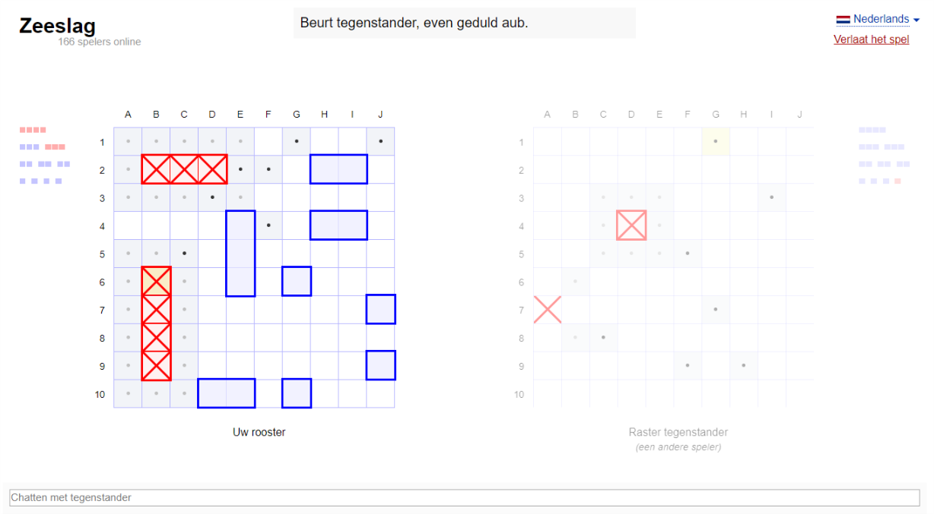

Game 2:

<https://boomboomboat.com/play#vanilla=357267>

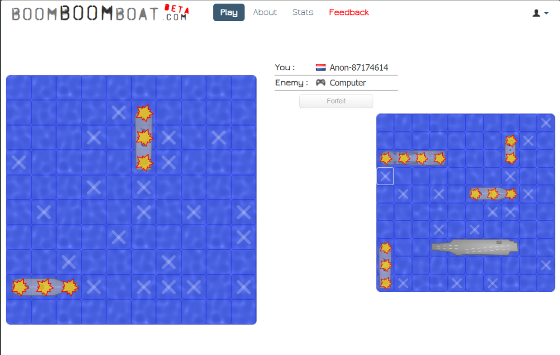

Game 3:

<https://www.mathplayground.com/battleship.html>

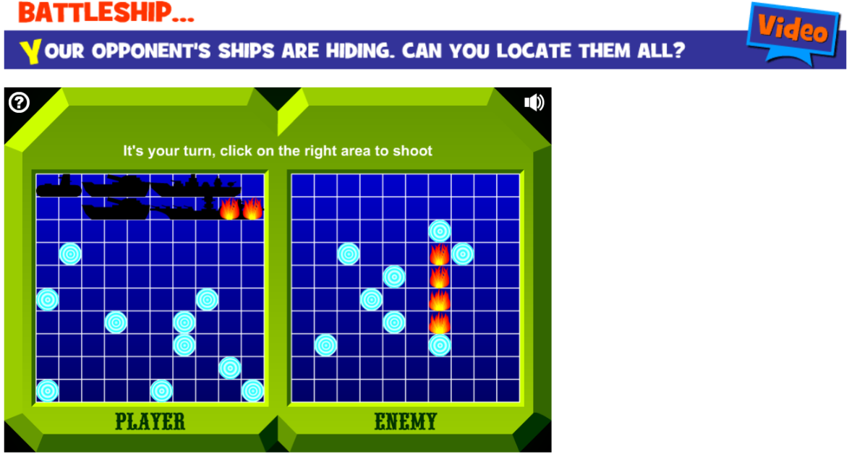

Game 4:

<http://www.primarygames.com/puzzles/board/battleshipwar/>

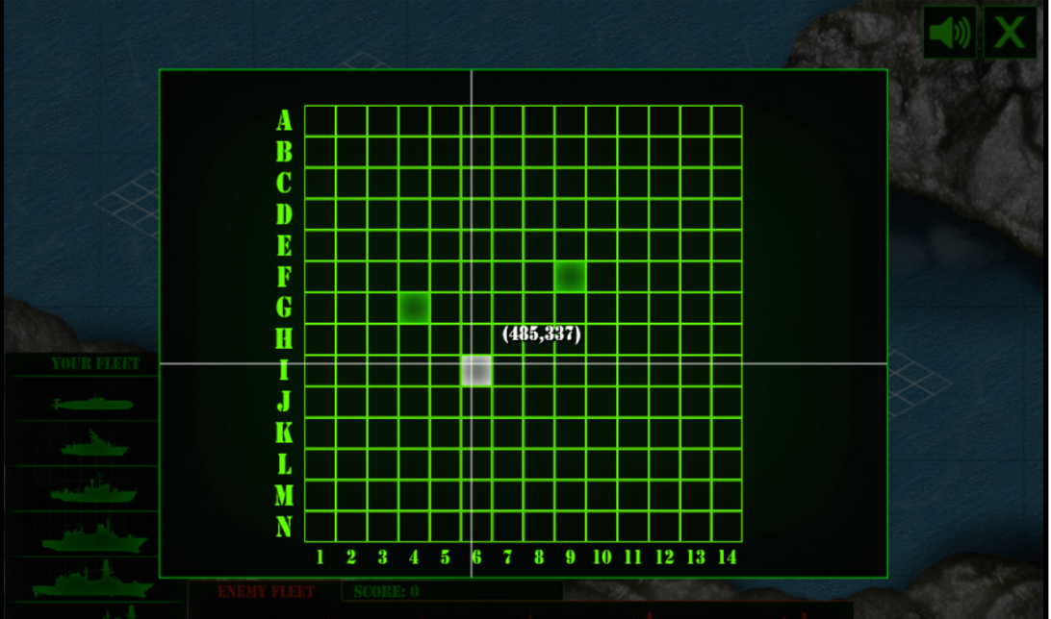

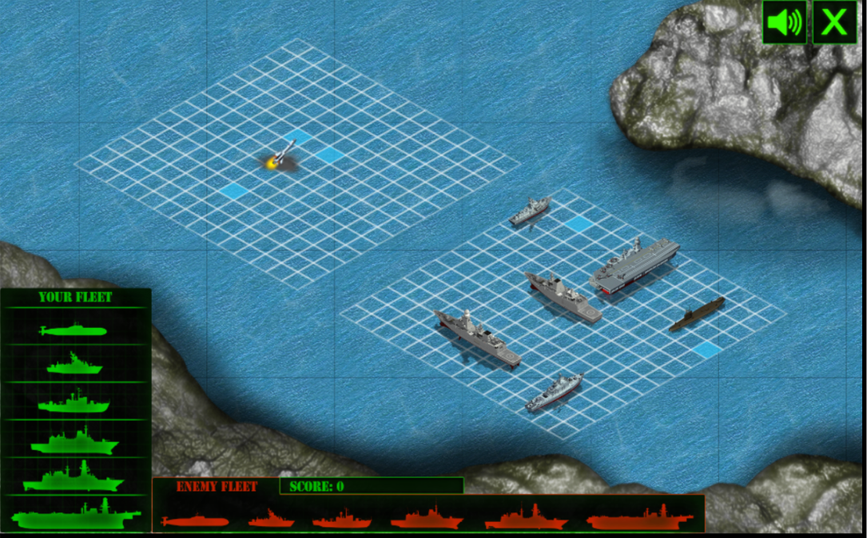

Design rules:

1. Don’t make me think
2. Minimize noise and clutter
3. If you cannot make it self-evident, make it self-explanatory

*Game 1:*

(1): The UI is pretty self-explanatory, it is easy to see that the blue cubes are the ships, and that the red crosses are the places that have been guessed right. The dots that appear when you want to select a box also explain pretty well that your shot will be placed on that box.

(2): Noise and clutter is highly minimized, the UI is very clean and there is not much clutter.

(3): The red crosses are very self-explanatory, you can see easily that those are the places that have been hit. The little squares on the sides of the fields are the ships that still remain/are hit.

*Game 2:*

(1): Clicking the squares to place your hit is pretty self-explanatory. The explosions and crosses indicating the hits/misses respectively is also quite self-explanatory.

(2): noise and clutter is also quite minimal, the interface is clean and there is not much clutter.

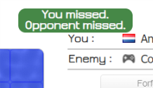(3): This principle is not used that much, as a message indicating who hit/missed is displayed after each turn:

*Game 3:*

At the start, when you are asked to move the ships in your desired place, you need to click the ship and move to the location, rather than click and drag, which is pretty counterintuitive. The instructions are and if you haven’t it is still doable but you may have no idea how to win, but that will work out itself if you just follow the instructions. As a user you don’t have to think too much as there are self-evident buttons for placing the ships and firing is aided with a short line stating that you should click in the right area of the board. The board/ site is very clear with other segments out of the picture in dedicated areas.

*Game 4:* There are no instruction so you should already know what battleship is, it made me think. It is not rally clear how you should place your ships. There is an animation between shots and you change between 2 kind of screens, there are also distracting coordinate lines whenever you hover over the board. The site really lacks any kind of explanatory stuff, the game itself and the goal.

4.3)

*Game 1:*

Good:

1. You get hints for where the enemy’s ships might be (indicated with the dots)
2. Clear view of your board and the opponent’s board
3. Able to see which ships still need to be destroyed

Bad:

1. No sound / sound effects
2. No animations
3. Can’t choose where to place your ships at the start of the game

*Game 2:*

Good:

1. Animated water
2. Ships fade in when you have destroyed them
3. Clear view of who hit/missed (indicated by the text)

Bad:

1. No sound / sound effects
2. No indication of which enemy ships are still to be destroyed
3. Able to see how many players are online and who they are/which country they come from

*Game 3:*

Good:

1. Sound effects on hits and misses, background music
2. Clear hit and miss targets
3. Simple grid pattern board

Bad:

1. No feedback about the opponent’s ships
2. Hard to know how many blocks a ship is (which ships you still have to destroy)
3. Unable to see your score

*Game 4:*

Good:

1. Very nice animations
2. Sound effects
3. Clear indication of where you placed your shot, also the coordinates are given.

Bad:

1. Can’t see your own board clearly
2. Waiting time caused by animations and changing views
3. Option to play other games inside game screen

5.1)

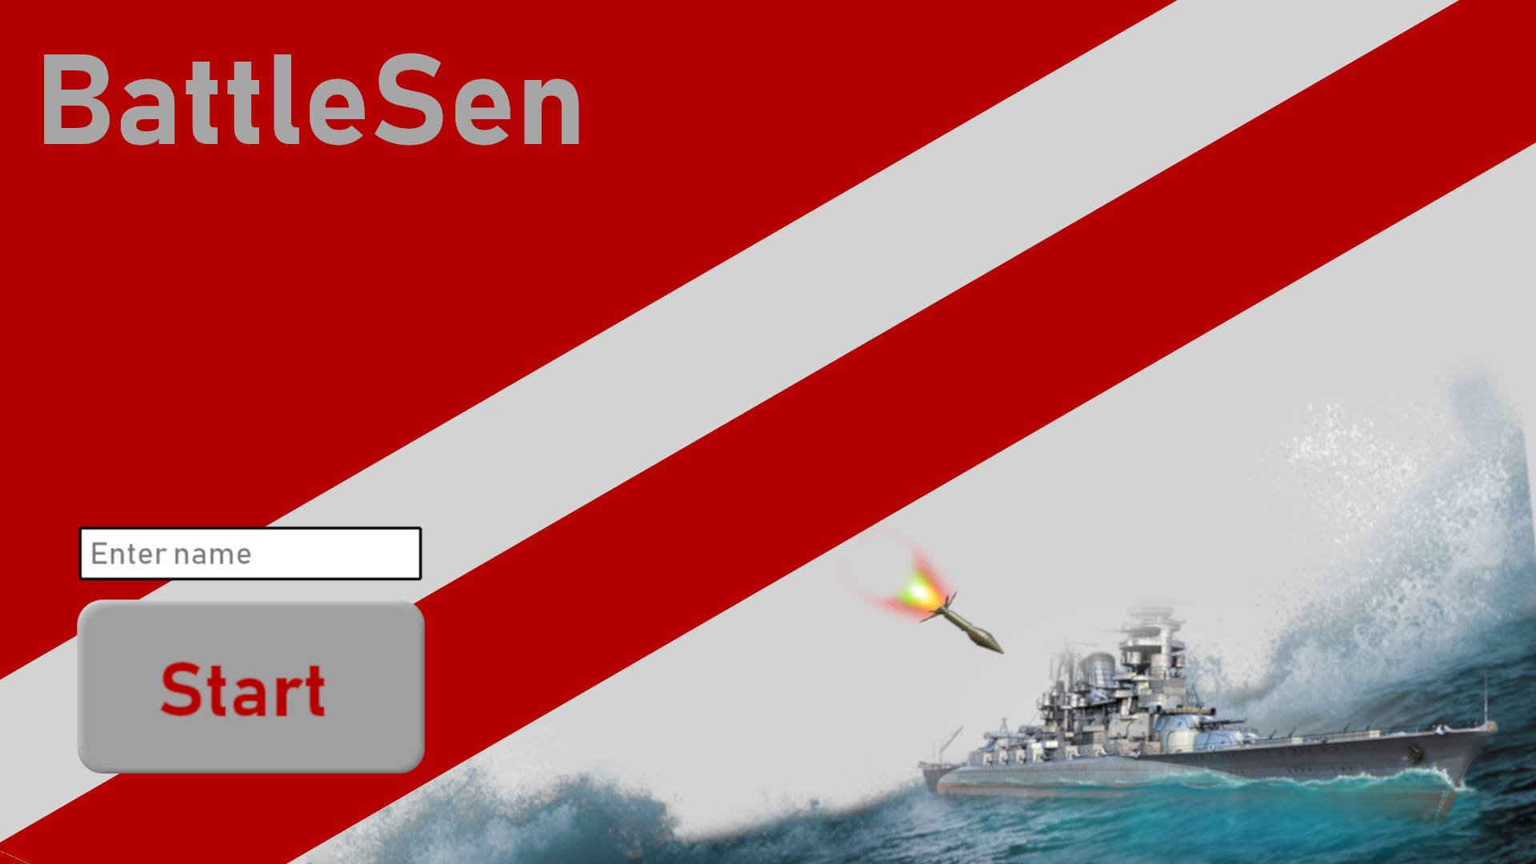

5.2)

